Article Title: Times New Roman Bold size 18

Abstract
All articles must include an abstract of no more than 250 words. An abstract is the window into your article. It should summarize the entire article including approach methods, findings etc. It should be written in accessible language avoiding jargon and should not include any references.
Article Type: (please indicate article type (e.g Original Research, Spotlight on Scholarship, etc.), this will be removed after acceptance)

1. Introduction
This is some left aligned single spaced paragraph text in Times New Roman 12. This is some paragraph text in Times New Roman 12. This is some paragraph text in Times New Roman 12. This is some paragraph text in Times New Roman 12. This is some paragraph text in Times New Roman 12. This is some left aligned single spaced paragraph text in Times New Roman 12. This is some paragraph text in Times New Roman 12. This is some paragraph text in Times New Roman 12. This is some paragraph text in Times New Roman 12. This is some paragraph text in Times New Roman 12
This is some left aligned single spaced paragraph text in Times New Roman 12. This is some paragraph text in Times New Roman 12. This is some paragraph text in Times New Roman 12. This is some paragraph text in Times New Roman 12. This is some paragraph text in Times New Roman 12. This is some left aligned single spaced paragraph text in Times New Roman 12. This is some paragraph text in Times New Roman 12. This is some paragraph text in Times New Roman 12. This is some paragraph text in Times New Roman 12. This is some paragraph text in Times New Roman 12
This is some left aligned single spaced paragraph text in Times New Roman 12. This is some paragraph text in Times New Roman 12. This is some paragraph text in Times New Roman 12. This is some paragraph text in Times New Roman 12. This is some paragraph text in Times New Roman 12. This is some left aligned single spaced paragraph text in Times New Roman 12. This is some paragraph text in Times New Roman 12. This is some paragraph text in Times New Roman 12. This is some paragraph text in Times New Roman 12. This is some paragraph text in Times New Roman 12
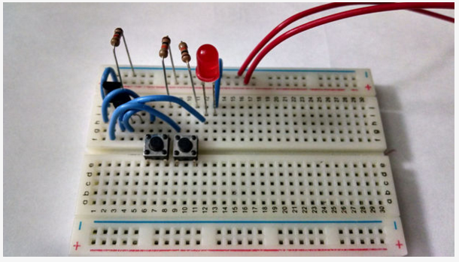
Figure 1: Caption below figure in Times New Roman bold size 12

2. Methods
This is some left aligned single spaced paragraph text in Times New Roman 12. This is some paragraph text in Times New Roman 12. This is some paragraph text in Times New Roman 12. This is some paragraph text in Times New Roman 12. This is some paragraph text in Times New Roman 12. This is some left aligned single spaced paragraph text in Times New Roman 12. This is some paragraph text in Times New Roman 12. This is some paragraph text in Times New Roman 12. This is some paragraph text in Times New Roman 12. This is some paragraph text in Times New Roman 12
This is some left aligned single spaced paragraph text in Times New Roman 12. This is some paragraph text in Times New Roman 12. This is some paragraph text in Times New Roman 12. This is some paragraph text in Times New Roman 12. This is some paragraph text in Times New Roman 12. This is some paragraph text in Times New Roman 12. This is some paragraph text in Times New Roman 12. This is some paragraph text in Times New Roman 12. This is some paragraph text in Times New Roman 12. This is some paragraph text in Times New Roman 12. This is some paragraph text in Times New Roman 12

3. Results
This is some left aligned single spaced paragraph text in Times New Roman 12. This is some paragraph text in Times New Roman 12. This is some paragraph text in Times New Roman 12. This is some paragraph text in Times New Roman 12. This is some paragraph text in Times New Roman 12. This is some left aligned single spaced paragraph text in Times New Roman 12. This is some paragraph text in Times New Roman 12. This is some paragraph text in Times New Roman text in Times New Roman 12. This is some paragraph text in Times New Roman 12
This is some left aligned single spaced paragraph text in Times New Roman 12. This is some paragraph text in Times New Roman 12. This is some paragraph text in Times New Roman 12. This is some paragraph text in Times New Roman 12. This is ew Roman 12. This is some paragraph text in Times New Roman 12. This is some paragraph text in Times New Roman 12. This is some paragraph text in Times New Roman 12. This is some paragraph text in Times New Roman 12. This is some paragraph text in Times New Roman 12. This is some paragraph text in Times New Roman 12

3.1 A subheading Times new Roman 13.5
This is some left aligned single spaced paragraph text in Times New Roman 12. This is some paragraph text in Times New Roman 12. This is some paragraph text in Times New Roman 12. This is some paragraph text in Times New Roman 12. This is some paragraph text in Times New Roman 12. This is some paragraph text in Times New Roman 12. This is some paragraph text in Times New Roman 12. This is some paragraph text in Times New Roman 12. This is some paragraph text in Times New Roman 12. This is some paragraph text in Times New Roman 12

4. Findings
This is some left aligned single spaced paragraph text in Times New Roman 12. This is some paragraph text in Times New Roman 12. This is some paragraph text in Times New Roman 12. This is some paragraph text in Times New Roman 12. This is some paragraph text in Times New Roman 12. New Roman 12. This is some paragraph text in Times New Roman 12. This is some paragraph text in Times New Roman 12. This is some paragraph text in Times New Roman 12

5. Discussion
This is some left aligned single spaced paragraph text in Times New Roman 12. This is some paragraph text in Times New Roman 12. This is some paragraph text in Times New Roman 12. This is some paragraph text in Times New Roman 12. This is some paragraph text in

6. Conclusion
This is some left aligned single spaced paragraph text in Times New Roman 12. This is some paragraph text in Times New Roman 12. This is some paragraph text in Times New Roman 12. This is some paragraph text in Times New Roman 12. This is some paragraph text in Times New Roman 12. This is some paragraph text in Times New Roman 12. This is some Times New Roman 12. This is some paragraph text in Times New Roman 12

References
Finney, J. (1970). Time and again. New York, NY: Simon and Schuster.
Nevin, A. (1990). The changing of teacher education special education. Teacher Education and Special Education: The Journal of the Teacher Education Division of the Council for Exceptional Children, 13(3-4), 147-148.
Jameson, J. (2013). E-Leadership in higher education: The fifth “age” of educational technology research. British Journal of Educational Technology, 44(6), 889-915. doi: 10.1111/bjet.12103

